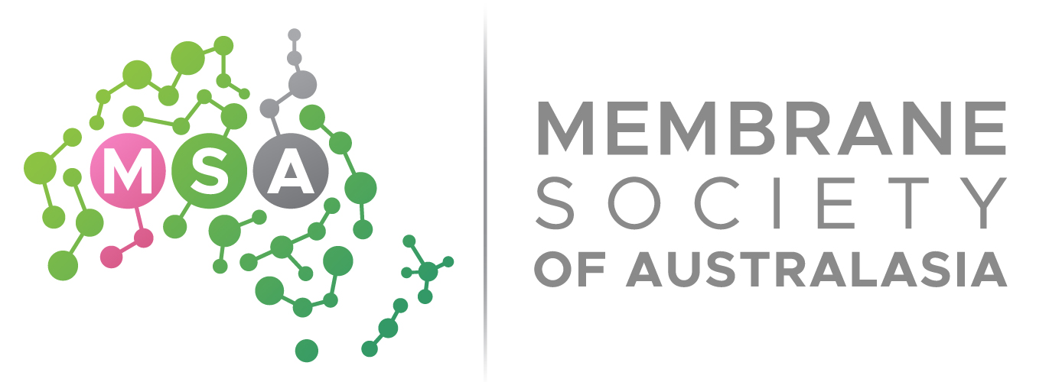  ACN 134 913 625 | (i)Nomination form for the MSA AWARDS 2024

Date: ____________________

I, the undersigned, being a/an □ Corporate Member
□ Individual Member
(note: Student, Individual and Honorary members are considered Individual Members)
wish to nominate:
Title:
Name (First, Last):
Current affiliation:
Contact email (of nominee):
Award category (see list on the next page):
I, ______________________ accept nomination as described above.
[NOMINEE NAME – IN BLOCK LETTERS]

Signature of Nominee/date:
Nominated by:
Signature of Nominator/date:
Name/Signature of additional Nominator/date (optional):

----------------------------------------------------------------------------------------------------------------

Note: The assessment panel and the MSA board reserve the right not to award any nominees in the respective category if no one meets the expected quality and calibre for an awardee.

-In a maximum of 200 words, describe and demonstrate why the nominee deserves the nominated award.
-Please attach (ii) 2-page CV of the nominee and (iii) any relevant supporting documents related to the claim (please submit as one PDF document containing (i) nomination form, (ii) and (iii)

The nominator shall return this form by email to Dr Soo Leong and A/Prof Huacheng Zhang by 5.00 pm (AESDST) on November 11th, 2024. By Email : secretary@membrane-australasia.org and cc to huacheng.zhang@rmit.edu.au

Award categories:
- MSA Student Award, for an outstanding student (Master or PhD) with strong track record and demonstrated research outcomes in the field of membrane technology
- MSA ECR Award, for an outstanding ECR (within five years post PhD completion) with a strong track record and excellent research outcomes in the field of membrane technology
- MSA Mentor Award, for a senior MSA member who contributed immensely in mentoring junior researchers
- MSA Service Award, for an individual who is dedicated to MSA's operation and management.
- MSA Membrane Science Award, for an individual or team who made significant breakthroughs in membrane science, demonstrated by high impact journal papers.
- MSA Applied Research Award, for an individual or team who made significant contribution on technology translation from lab to industry.
- MSA Collaboration Award, for a team (2 up to 5 members) that demonstrated strong cross-cutting collaboration between two or more organisations resulting in significant outputs to the field of membrane technology.
Eligibility Criteria
- Only MSA members holding a valid MSA membership for a minimum of 1 year expiring not before 01 September 2024 can be eligible to nominate or be nominated for the awards.

- Individual, student, corporate and honorary memberships are automatically granted eligibility rights.

- A nominee can only be nominated to only one Award category.

- No self-nomination is allowed.

- Eligible candidates are nominated through a nomination form. The nomination forms shall be returned to the MSA secretary to verify the eligibility.

Judging process: Nominations for this award will be assessed by an assessment panel appointed by the MSA Board. The panel will base its assessment on the track record of the nominee, the strength of claims and evidence provided to support the claims. After the panel has deliberated and selected the award winner, they will forward the decision to the MSA Board for final confirmation.

Awards selection timeline:
Event | Date
MSA call for nominations open | 01/09/2024
Call for nominations close | 11/11/2024
Awards outcomes | 9 Dec 2024 (MSA AMC 2024 CONFERENCE DINNER)

